**Missouri River SEASCORR Analysis**

**Maximum Temperature -**

Data Information -

*Maximum temperature taken from High Plains Regional Climate Center ‘CLIMOD’ (climod.unl.edu). Station name – BISMARCK MUNI AP, Bismarck North Dakota. Coop ID – 320819, 1874 – 2017.*

SEASCORR plots - (primary maximum temperature, secondary precipitation)

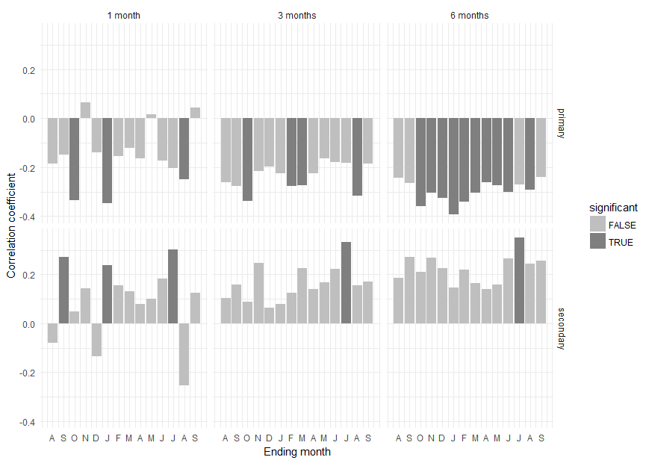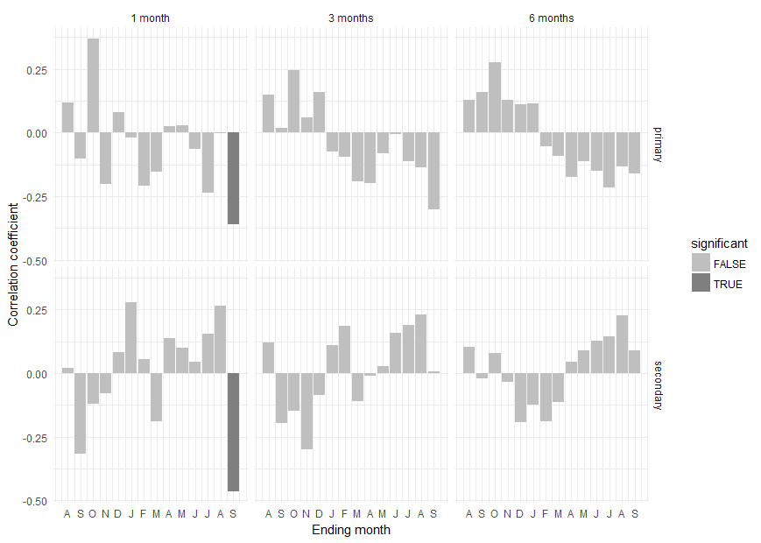Cross Ranch 1921 – 1953 Cross Ranch 1954 - 2014

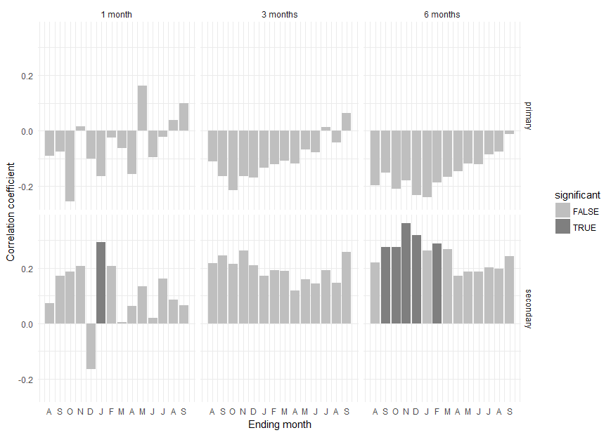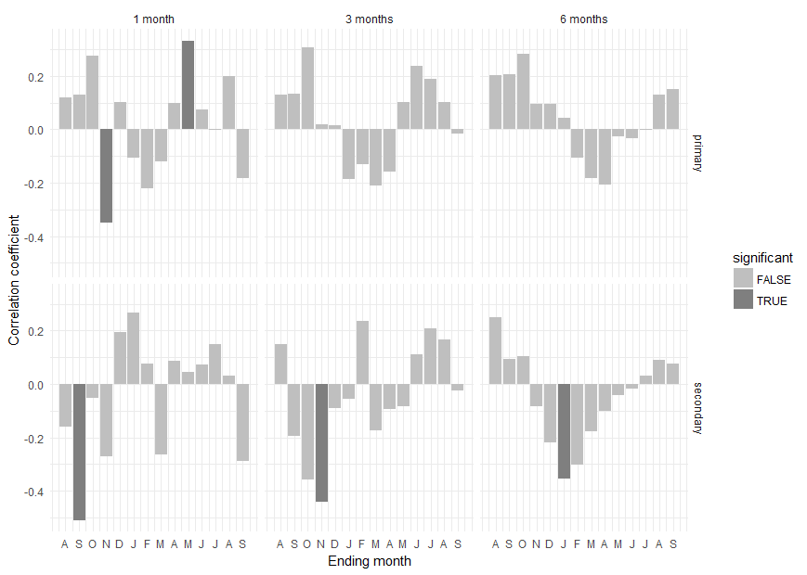Smith Grove 1921 – 1953 Smith Grove 1954 - 2014

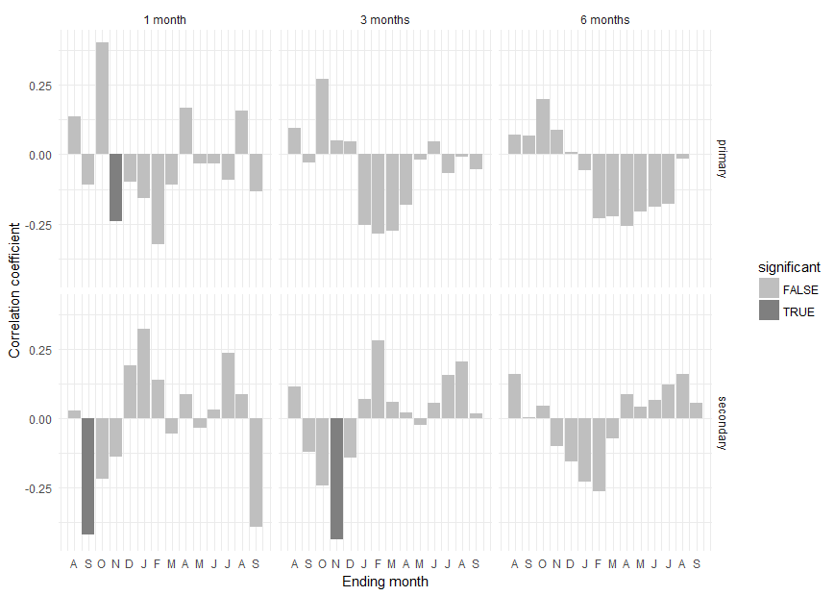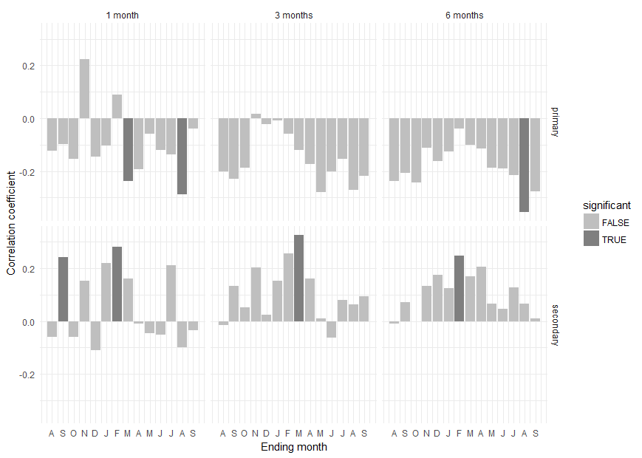Kimball Bottoms 1921 – 1953 Kimball Bottoms 1954 – 2014

Summary –

Correlation between maximum temperature and tree rings is very weak in each of the three sites before the garrison dam is installed. After the installation of the dam, Cross Ranch exhibits a weak but persistent negative correlation with maximum temperature. Strongest correlations are occur in the winter. Smith Grove mostly shows the same relationship, however no correlation is considered strong enough to be significant. Strongest correlations are present in the winter. Kimball Bottoms mostly mimics Smith Grove’s lack of significant correlations, except for 3 periods. Strongest correlations are in the current year’s August.

Overall, maximum temperature goes from no relationship, to a weak negative correlation with the dam’s installation. At its strongest (Cross Ranch), a correlation coefficient of 0.3 suggests that the effect is minor.

**Precipitation -**

Data Information –

*Precipitation records taken from High Plains Regional Climate Center ‘CLIMOD’ (climod.unl.edu).*

*Station name – BISMARCK MUNI AP, BISMARCK North Dakota, Coop ID – 320819, 1874 – 2016.*

SEASCORR plots – (primary precipitation, secondary maximum temperature)

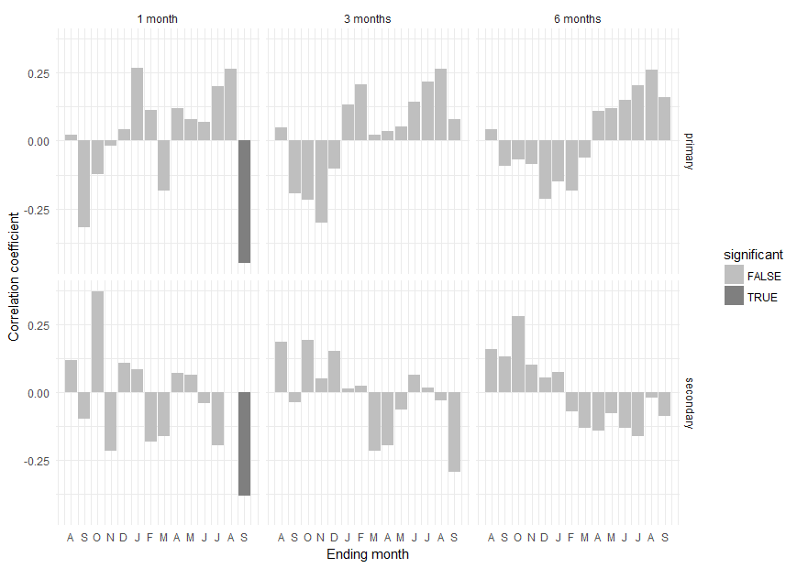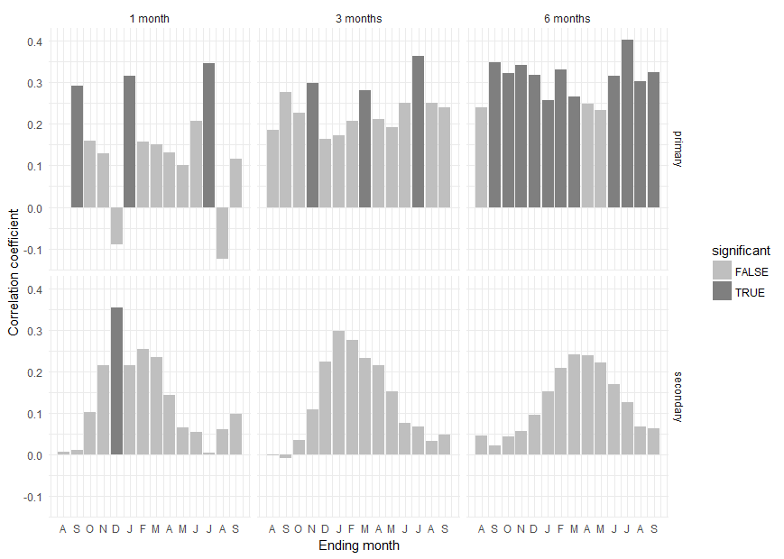Cross Ranch 1921 – 1953 Cross Ranch 1954 - 2014

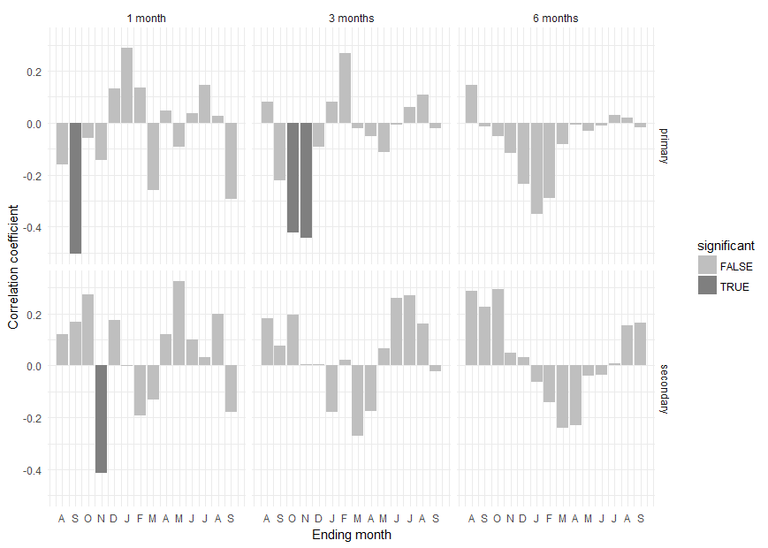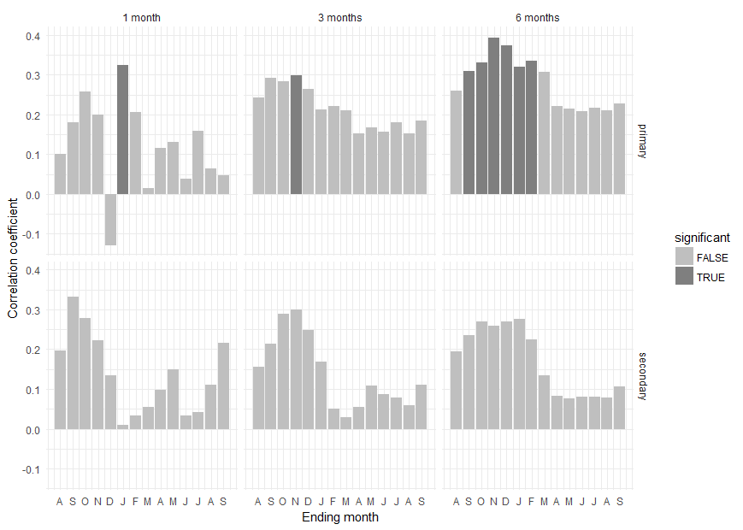Smith Grove 1921 – 1953 Smith Grove 1954 – 2014

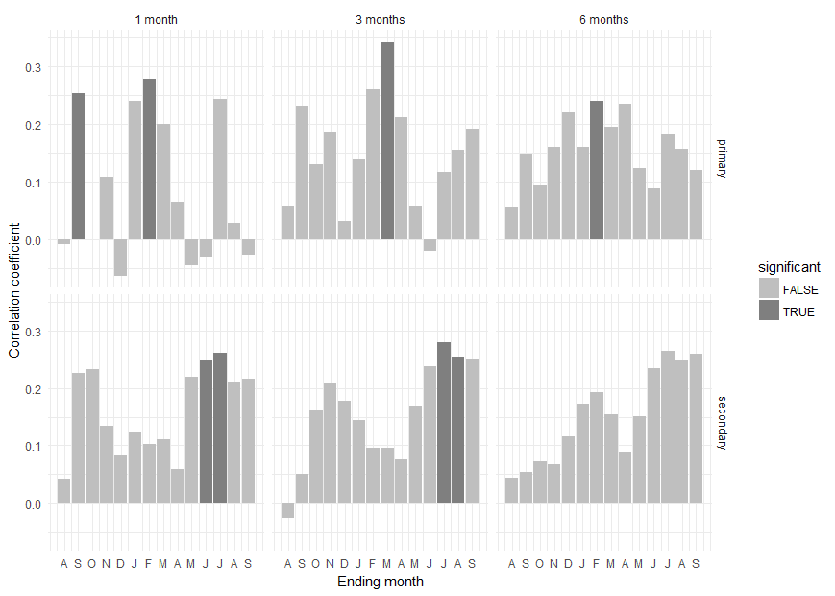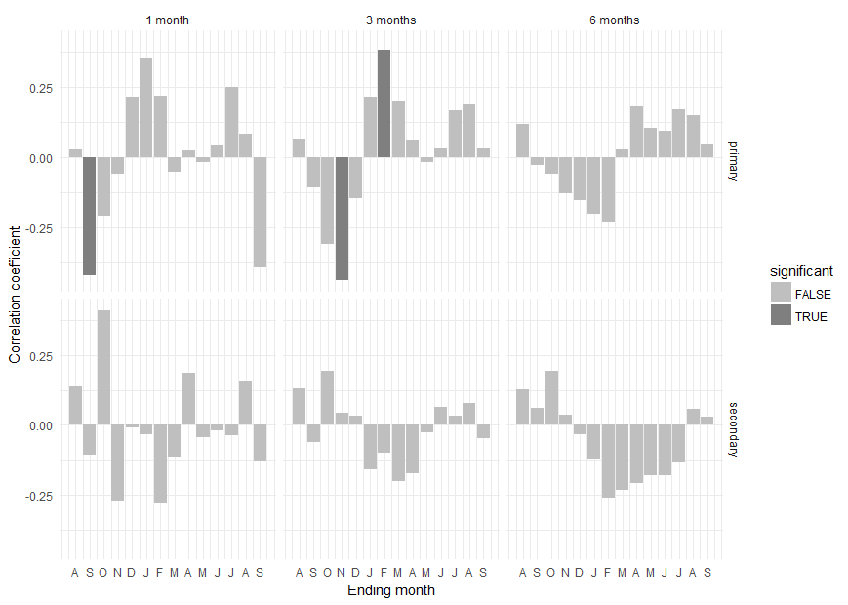Kimball Bottoms 1921 – 1953 Kimball Bottoms 1954 - 2014

Summary –

Cross Ranch correlation with precipitation is nearly nonexistent pre-1953. After the dam’s instillation, Cross Ranch is weakly (0.3) but consistently positively correlated with Bismarck precipitation. Smith Grove shows a similar pattern, with the post dam correlations concentrated in the previous year’s fall / winter. Kimball Bottoms moves from no correlation with precipitation, to a weak, unreliable positive correlation post-1953.

Overall, all three sites exhibited basically no relationship Bismarck’s precipitation data before 1953. Each of the three sites exhibited weak (0.3) but consistent positive correlations with precipitation post-dam construction. The best correlations occur at Cross Ranch, the worst at Kimball Bottoms.

**Flow -**

Data Information –

*Discharge, cubic feet per second, taken from USGS NWIS (waterdata.usgs.gov/nwis). Station name – USGS 06342500 Missouri River at Bismarck, ND.*

I emailed an inquiry about the data restriction to Steven Robinson, the acting deputy director at USGS Dakota Water Science Center.His reply on the quality of the pre-1953 data is shown below.

*“Fisher,*

*The flows at Bismarck have been regulated by Garrison Dam since its completion in 1953. The USGS typically does not compute any statistics for both unregulated and regulated periods. We will do them separately but because of the regulation comparing pre- and post- regulation periods statistically has little meaning or value.*

*The discharge values prior to 1953 have been approved and are valid for that time period.”*

* *Steven Robinson*

After I got the go ahead, I collected the pre-1953 flow data and tried to run it through seascorr, but the R version of seascorr must have 31 years of overlapping data to run. Unfortunately, the flow data only extends back partially to 1928. This forced my minimum period of analysis to 1930 – 1961, which includes 7 years of post-dam data. Perhaps the Matlab version can do better? Regardless, these are the results I was able to get from this timeframe.

SEASCORR plots - (primary Missouri River flow (cfs), secondary precipitation)

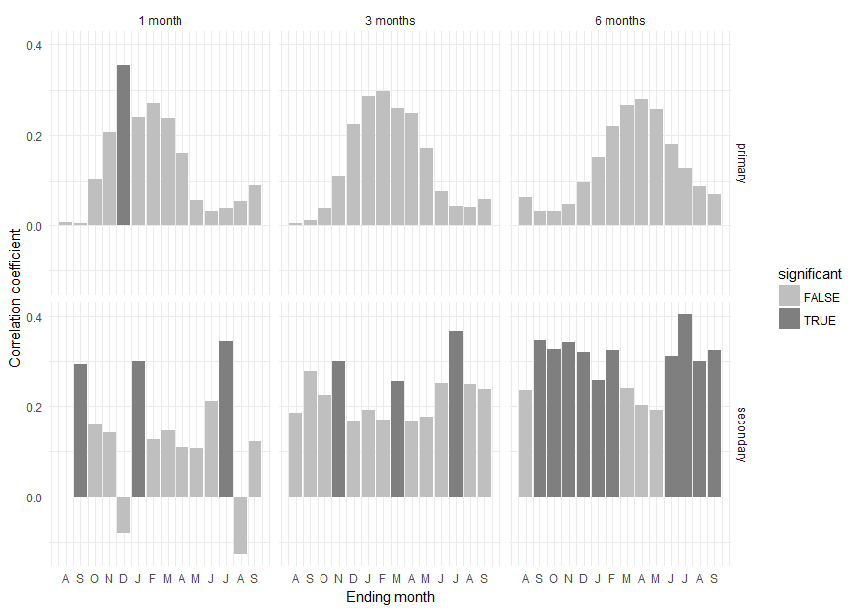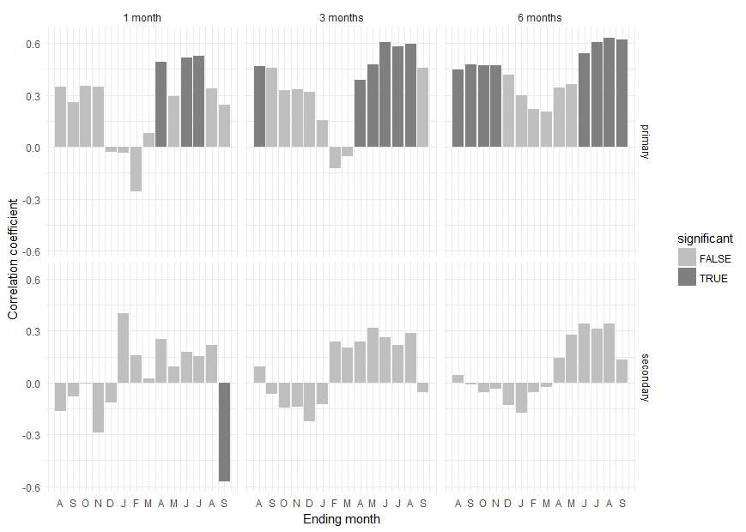Cross Ranch 1930 – 1961 Cross Ranch 1954 - 2014

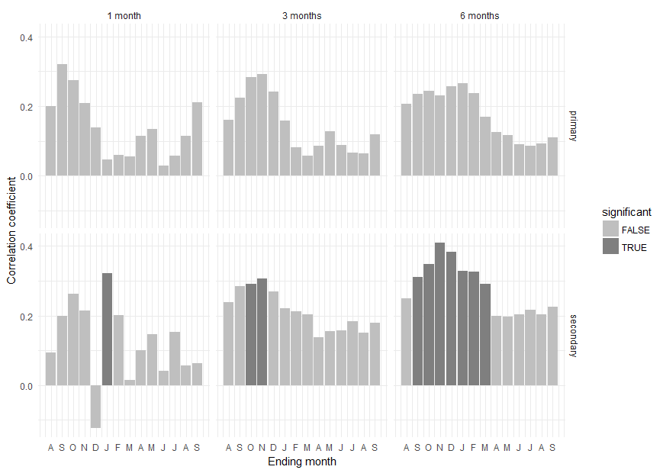Smith Grove 1930 – 1961 Smith Grove 1954 - 2014

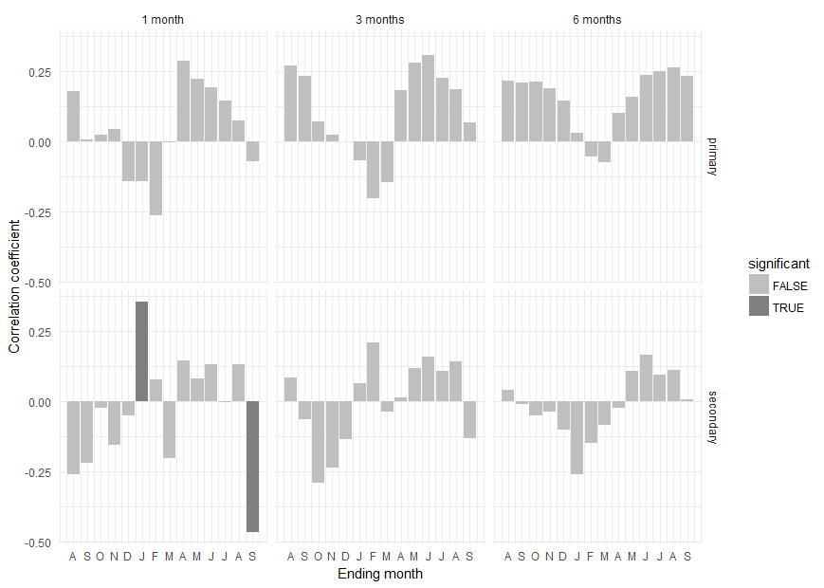

Kimball Bottoms 1930 – 1961 Kimball Bottoms 1954 – 2014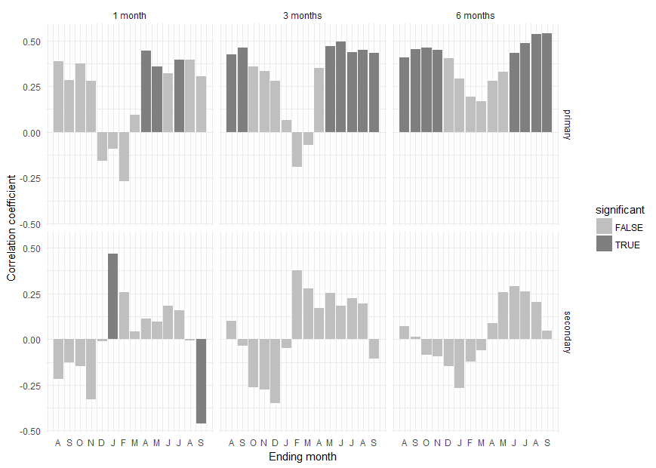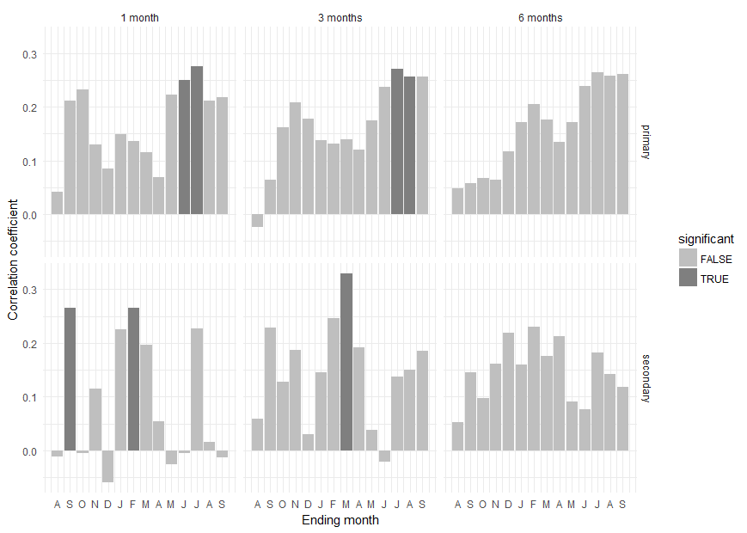

Summary –

Cross Ranch is significantly, positively correlated with flow pre-1960. Correlation coefficients of 0.6 can be seen in the current year spring / summer. Correlation drops considerably post 1953, moving to a peak of 0.3 present around February. Smith Grove shows an insignificant, variable correlation to flow pre-1960. Post 1953 the site shows a slightly stronger, positive correlation centered on the previous year’s October. The coefficients are still weak (<0.3) and insignificant. Kimball Bottoms exhibits a moderate (0.45) positive correlation with flow, pre-1960. The highest correlations occur during the previous year’s August through November, and the current year’s June – September. Post 1954 the correlations are still positive, but drop to 0.25 at best. They’re centered on the current year’s June / July.

In conclusion, Cross Ranch and Kimball Bottoms act much as we would expect, dropping their correlation with flow significantly post-1954. Smith Grove increases correlation with flow with the installation of the Garrison Dam - this could be a mistake, given that the ‘pre-dam’ data actually includes 6 years of post-dam flow. Pre-dam correlations at Cross Ranch and Kimball Bottoms are the highest we’ve seen of any influence, reaching as high as correlation coefficient 0.6.

**Palmer Drought Severity Index –**

**I’m still working on gathering this data, it’s proven to be a bit harder than I thought to track down a simple table with values. Everywhere I look wants me to download the data via “netCDF” software, and manipulate it.**

Data Information –

SEASCORR plots - (primary PDSI, secondary ----)